User Guide

Odyssey desktop reader v2.0

Table of Contents
1 Introduction 3
2 What’s in the Box 4
3 Key Descriptions 4
4 Instructions 7
4.1 Powering On or Off 7
4.2 Sleep Mode 7
4.3 Unfolding and Stowing the Camera Arm 7
4.4 Adjusting the Device Volume 7
4.5 LED Light Indicators 8
4.6 Battery Level Reminder 8
4.7 Text Recognition (OCR) 8
4.7.1 Auto Mode 8
4.7.2 Manual Mode 8
4.7.3 Finger Mode 9
4.8 Desktop reader requirements 9
4.9 Reading Text 10
5 Settings 11
5.1 File Management 11
5.1.1 Deleting a document 11
5.2 Reading Speed 12
5.3 Voice 12
5.4 Wi-Fi 12
5.5 Bluetooth 13
5.5.1 Disconnecting a Bluetooth headset 13
5.6 Settings 13
5.6.1 LED Settings 13
5.6.2 Sleep Settings 14
5.6.3 Recognition Sound 14
5.6.4 Language Settings 14
5.6.5 Sleep Time Setting 14
5.6.6 Time Zone 14
5.6.7 Reading Setting 15
5.6.8 Simple Mode 15
5.6.9 About 15
5.6.10 User Manual 16
6 Precautions 16
7 Disclaimer 17
8 Technical Specifications 18
9 Warranty 18
10 QR codes 19

Introduction
Thank you for purchasing the Odyssey desktop reader.
HumanWare is committed to offering the most efficient and user-friendly desktop reading solutions. The Odyssey desktop reader features essential user requirements such as accurate text detection and superior sound quality is easy to set up and use so that you can start scanning and reading a wide range of printed materials shortly after unboxing.
Please read the operating and safety instructions in this user guide prior to using the device. If you have any questions about your system, please contact HumanWare Customer Service (coordinates are listed at the back of this user guide).
HumanWare takes great pride in offering a quality product that meets both your needs and expectations.

Copyright 2024 by Technologies HumanWare Inc., all rights reserved. No part of this publication may be reproduced or distributed in any form or by any means, or stored in a database or retrieval system, without the prior written permission of Technologies HumanWare Inc.

What’s in the Box

- Odyssey desktop reader
- Power cord
- Power adapter
- Printed User Guide

Key Descriptions and technical features

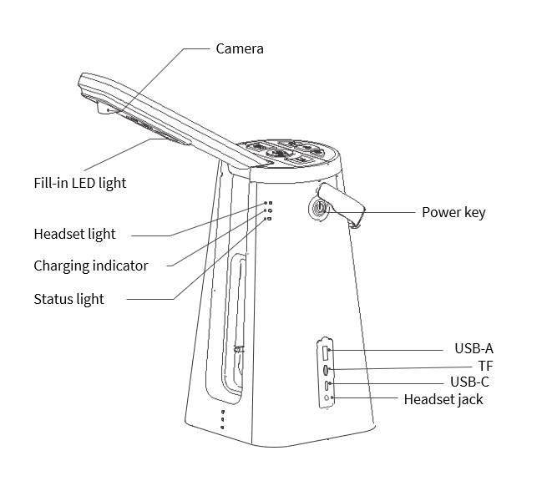
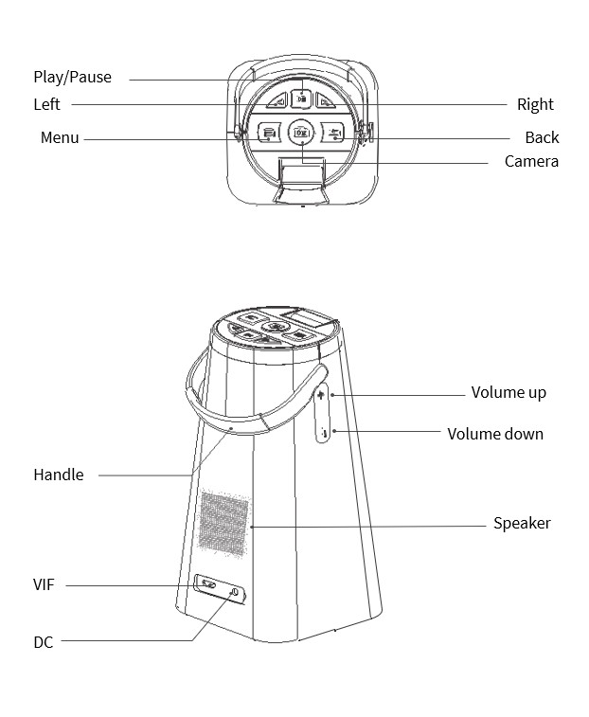

Instructions

Powering On or Off
- To power on your device: Press and hold the Power key for 3 seconds. You will hear a "beep" and the blue status indicator light will indicate that the device is successfully powered on. A voice will announce, “Auto mode. Open the camera arm.”
- To power oﬀ the device: press and hold the Power key for 3 seconds. You will hear a music jingle, indicating that the device has been successfully powered off.

Sleep Mode
The reader enters Sleep mode if no operations are performed within 3 minutes (default).
- Press the Power key to manually enable Sleep mode.
- Pressing the Power key in Sleep mode will wake up the reader.

Unfolding and Stowing the Camera Arm
The camera arm opens from the main unit by lightly depressing the bottom of the arm, just above the three tactile dots, until you hear a “click”. The camera arm will slowly raise itself into the reading position.
Always remember to safely stow the camera arm before moving or transporting the device. This is done by gently pressing down on the camera arm until you hear it “click” into its locked position.

Adjusting the Device Volume
The Volume up/down toggle button is located on the left side of the reader, just below the carry handle attachment point.
- Press the Volume up/down key in any mode to adjust the system volume.

LED Light Indicators
Powered on | Blue LED lights up
Operational | Blue LED light remains on
Sleep mode | Blue LED light blinks
Powered off | LED lights turn oﬀ
Charging | Red LED lights up
Battery fully charged (100%) | Green LED lights up
Bluetooth connection established | Green LED lights up

Battery Level Reminder
- When the charger is plugged in or disconnected, the reader will announce the current battery level.
- When the battery level is lower than 10%, the reader will automatically announce a low battery reminder.

Text Recognition (OCR)
Text recognition is available in three modes: Manual mode, Finger mode and Auto mode (note that Auto mode is the default mode when the device is powered on the first time). Simply press the Left or Right arrow keys to cycle through the three modes.

Auto Mode
- Press the Left or Right arrow keys to access Auto mode.
- Place your reading material directly under the reader and align it with the three tactile dots at the base of the reader. If the document isn’t aligned properly, you will hear “place the text material under the camera,” or “move text up.”
When you hear the camera shutter sound, it indicates that the photo has been taken successfully. The reader will automatically start to read the document aloud.

Manual Mode
- Press the Left or Right arrow keys to access Manual mode.
- Place your reading material directly under the reader and align it with the three tactile dots at the base of the reader.
- Press the Camera key. When you hear the camera shutter sound, it indicates that the photo has been taken successfully. The reader will automatically start to read the document aloud.

Finger Mode
- Press the Left or Right arrow keys to access Finger mode.
- Place your reading material directly under the reader and align it with the three tactile dots at the base of the reader.
- Place your index ﬁnger under the text that you would like read aloud. The double "beep" sound indicates that the photo has been taken successfully and the player will start reading 3 lines above where the finger is located.

Desktop reader requirements
By following the basic recommendations listed below, your Odyssey desktop reader will render excellent results.
- Note that sufficient contrast is required for the Odyssey desktop reader to function properly.
- Please be certain that the reading material is non-reflective, as laminated documents or glossy objects (credit cards, for example) may pose problems for the camera lens.
- Always use the reader under normal lighting conditions.
- Be certain that documents remain still when taking pictures of them.
- When taking pictures, ensure that the camera is aligned and centered with the reading material (use the three tactile dots at the base of the unit as a reference).


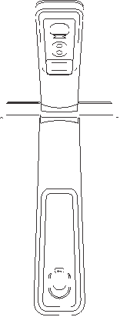

A4
A3

Note: Standard (A3) paper size is the reader’s maximum recognition range.

Reading Text
- Press the Play/Pause key at any time to start, stop or continue reading text.
- While reading text, you can press and hold the Menu key to save the current text, the Odyssey will announce, “Saving… saved successfully.”
- While reading text, you can press the Left key to go back to (rewind) text which was just read aloud or press the Right key to skip over text (fast forward).
- In the process of reading text, press the Back key to return to text recognition mode.
You will hear a double bell-chime when the reader has finished reading the document, and it will automatically return to Text Recognition mode.

Settings
The Odyssey desktop reader allows you to personalize your user experience by offering a wide range of settings.
Press the Menu key to enter the Settings menu, you will hear “Main menu”, and the current battery level.
- Once you are in the Settings menu, you can press the Left or Right arrow keys to browse and access different Settings options. The Settings options are:

- File Management
- Reading speed
- Voice
- Wi-Fi
- Bluetooth
- Settings
- About
- User manual

- In the Settings menu, press the Camera key to access the next Settings level.
- Note that at the ﬁrst level of the Settings menu, you can press the Back key to exit the Settings menu.
- After you have changed a setting, press the Camera key again to save that setting (you can always press the Back key to cancel the setting).
- At the second level of the Settings menu, you can press the Back key to return to the upper level.

File Management
- Press the Menu key to enter the Main menu.
- Press the Left or Right arrow keys to access File management.
- Press the Camera key, the Odyssey will start reading the document titles.

Deleting a document
- Once you are on the document list page, press the Left or Right arrow keys to select a document.
- Press Play to play the document, or
- Press and hold the Menu key to delete the document.
Note that a document cannot be retrieved after it has been deleted.

Reading Speed
- Press the Menu key to enter the Main menu.
- Press the Left or Right arrow keys to go to Reading Speed settings.
- Press the Left or Right arrow keys to select Reading Speed setting. The speed range is from 1 (very slow) to 10 (very fast). 5 is the normal (default) Reading Speed.
- Press the Camera key to set the Reading Speed.

Voice
- Press the Menu key to enter the Main menu.
- Press the Left or Right arrow keys to go to Voice settings.
- Press the Camera key to enter the submenu of Voice settings.
- Press the Left or Right arrow keys to select a Reading voice (male or
female).
- Press the Camera key to save the setting.

Wi-Fi
Note: An Android or iPhone is required to configure Wi-Fi settings.
On your smartphone
- Download the corresponding app according to your mobile phone system*.
*Note: if you are using an Android smartphone, go to Google Play store, if you are using iPhone, go to the App store. Use the search term “AngelEye”.
- Open the app.
- Click “Desktop reader”.
- Enter the Network name and Password (both are case-sensitive).
- Press “Confirm” to generate the QR code.
On the Odyssey desktop reader
- Press the Menu key to enter the Main menu.
- Press the Left or Right arrow keys to go to Wi-Fi settings.
- Press the Camera key and follow the instructions that you will hear, “… download and place the QR code under the camera of the reader and press the Camera button (wait for QR recognition), then the reader will automatically connect to the network.”
If the connection fails, you will be prompted to connect to the network.
- Press the Camera button to reconnect or press the Back button to return to the previous menu.

Bluetooth
- Press the Menu key to enter the Main menu.
- Press the Left or Right arrow keys to go to Bluetooth settings.
The reader will announce “Searching for Bluetooth devices, please wait.”
- Press the Left or Right arrow keys to select Headset settings.
- Press the Camera key to enter the Headset submenu settings.
- Press the Left or Right arrow keys to switch between the detected Bluetooth headsets, then press the Camera key pair with a particular headset.
You will hear, "Bluetooth headset connected", indicating that the connection is successful.

Disconnecting a Bluetooth headset
- Press the Menu key to enter the main menu.
- Press the Left or Right buttons to switch from headset.
Bluetooth is automatically disconnected.

Settings

LED Settings
LED lights can be set to Auto, Steady On or LED Off
- Press the Menu key to enter the Main menu.
- Press the Left or Right arrow keys to select Settings.
- Press the Left or Right arrow keys to select LED Settings.
- Press the Left or Right arrow keys to select from Steady On, LED Off or Auto (automatically turns on or off depending on lighting conditions).
- Press the Camera key to confirm the setting.

Sleep Settings
- Press the Menu key to enter the Main menu.
- Press the Left or Right arrow keys to go to Sleep settings.
- Press the Camera button to select from 5, 10, 30, 60 or Never.
- Press the Camera button to set the Sleep setting.
Note: When the camera arm is enabled, the device goes to sleep when you fold in the arm. When the camera arm is disabled, the device does not automatically go into sleep mode.

Recognition Sound
- Press the Menu key to enter the Main menu.
- Press the Left or Right arrow keys to go to Recognition sound settings.
- Press the Left or Right arrow keys switch to select from Music (jingle), Click (clicking sound), Voice (message saying “please wait”) or Blank (no sound).
- Press the Camera key to set the Recognition sound setting.

Language Settings
- Press the Menu key to enter the Main menu.
- Press the Left or Right arrow keys to go to Language settings.
- Press the Left or Right arrow keys switch to select from American English, Canadian French or Mexican Spanish.
- Press the Camera key to set the Language setting.

Sleep Time Setting
- Press the Menu key to enter the Main menu.
- Press the Left or Right arrow keys to go to Sleep time settings.
- Select from 5 minutes, 10 minutes, 30 minutes, 60 minutes or Never sleep.
- Press the Camera key to set the Sleep time setting.

Time Zone
- Press the Menu key to enter the Main menu.
- Press the Left or Right arrow keys to go to Time zone settings.
- Press the Left or Right arrow keys switch to select from Montreal, Halifax, London, Amsterdam, Paris, Dubai, Shanghai, Tokyo, Sydney, Toronto, New York, Chicago, Edmonton, Vancouver or Winnipeg.
- Press the Camera key to set the Time zone setting.

Reading Setting
- Press the Menu key to enter the Main menu.
- Press the Left or Right arrow keys to go to Reading settings.
- Press the Left or Right arrow keys switch to select from Reading in order or Single page.
- Press the Camera key to set the Reading setting.

Simple Mode
Simple Mode disables all buttons except volume and play/pause.
- Press the Menu key to enter the Main menu.
- Press the Left or Right arrow keys to go to Simple mode.
- Select On or Off.
When Off is selected, you will hear “Set to simple mode Off”.
- Press the Camera key to set the mode.
When On is selected, you will hear “Open Simple mode? Yes.”
- Press the Camera key to set the mode. You will hear the message, “Press and hold the Back button for 5 seconds to exit Simple Mode”.
A confirmation message will announce “Exit Simple Mode”.

About
- Press the Menu key to enter the Main menu.
- Press the Left or Right arrow keys to access About.
- Press the Left or Right arrow keys to select from Software version, Factory reset or Software upgrade.

Software Version
When you press the press the Camera key to select Software version, a voice will read aloud the device serial number as well as the software and system version numbers.

Factory Reset
- Press the Camera key to select Factory Reset, a voice will ask “Perform factory reset? “Yes” or “No”.
- Press the Left or Right arrow keys to make your selection then press the Camera key to confirm or ignore the factory reset.
Note that the reader will automatically restore factory settings, but you can also press the Back key to cancel the restoration of factory settings.

Software Upgrade
Note: Be certain that Wi-Fi is connected before you select Software upgrade.
If there is a new software version, the voice will prompt an upgrade. Press the Camera key to start the upgrade. If the upgrade is successful, the voice will indicate, “upgrade successful”.
If there is no software upgrade exists, the voice will indicate that the current version is the most recent version.

User Manual
A variety of informative sections can be found in the user manual: Product overview, Powering On or Off, Text recognition/OCR, Settings, Sleep, Specifications, Precautions and Disclaimer.
Press the Left or Right arrow keys to make your selection then press the Camera key to access the content and have it read aloud.

Precautions
We recommend that you read this user guide carefully and follow all safety rules before using the Odyssey desktop reader.
- The reader must be handled gently: avoid any impact or vibration.
- Operate the reader in a clean environment.
- Avoid contact with harsh chemicals (such as benzene) and keep the reader away from strong magnetic or electric ﬁelds.
- Avoid direct sunlight.
- Avoid flames.
- Do not operate the reader in high temperature or high humidity environments.
- Do not soak or wash the reader as this may lead to an electric shock during use.
- Do not disassemble, repair, modify or replace any part of the reader.
- Discarded packaging, batteries, and electronic components must be properly disposed of.
- Use only the charger that comes with this product. Using an unauthorized charger may cause serious injury and may render the warranty invalid.
- Store the reader out of the reach of children.

Disclaimer
In order to protect the legitimate rights and interests of users, you must carefully read the user guide, disclaimer, and safety precautions provided related to this product before using it. NextVPU (Shanghai) Co., Ltd. reserves the right to update the preceding documents. This product must be operated in compliance with the user guide and safety precautions.

Once you start using this product, you will be deemed to have read, understood, approved, and accepted all the terms and contents of this user guide, disclaimer, and safety precautions. Users promise to be liable for their actions and all the consequences arising therefrom. Users promise to use this product only for legitimate purposes and agree to these terms and any relevant policies or guidelines formulated by NextVPU (Shanghai) Co., Ltd.

Requirements including but not limited to this user guide and safety precautions must be strictly observed and implemented during the use of this product. For all personal injuries, accidents, property losses, legal disputes, and other adverse events causing conﬂicts of interest owing to improper behaviors in violation of safety precautions or force majeure, users shall be liable for relevant responsibilities and losses, and NextVPU (Shanghai) Co., Ltd. shall not bear any liability.

NextVPU (Shanghai) Co., Ltd. shall not bear any liability for any violation of laws and regulations directly or indirectly caused by users' use of this product. NextVPU (Shanghai) Co., Ltd. shall not bear any liability for any indirect losses (including but not limited to losses in proﬁts, expected beneﬁts, business reputation, and time) caused by defects, ﬂaws, and repair of this product. The company's liability for compensation for this product and repair shall not exceed the actual amount paid by users for purchasing this product.

Technical Specifications

Model | SR-D1
Power | DC 5 V/2 A
Dimensions (camera stowed) | 280mm (H) x 155mm (W) x 150mm (D)
Dimensions (camera deployed) | 395mm (H) x 155mm (W) x 150mm (D)
Materials | ABS thermoplastic, anodized aluminum
Battery capacity | 6700mAh
Operating temperature | 0℃ to 40℃
RAM + Storage | 2 GB + 16 GB
Camera resolution | 13MP
Input and output | 3.5mm headset jack and video interface
Extension interfaces | USB-A x 1, USB-C x 1, SD card slot x 1
Fill-in LED light | Available
Run time (with full charge) | 15 hours

Warranty
This warranty covers defects in materials and workmanship for one year from the date of purchase, including both parts and labor. It does not extend to any accidental damage, misuse, or alterations made by the user. To obtain a warranty service, please retain your original proof of purchase and contact our customer service team.

QR codes



Scan the Android QR code to download the Reader application.



Scan the iOS QR code to download the Reader application.

